## RESA Price Survey

Here’s the challenge in staging…there are a few variables that can confuse our pricing and there’s really no such thing as “typical” pricing since we are a somewhat unregulated industry. Variables include whether a stager offers a Staging Report (or notepad), whether a stager allows for accessory rental, etc..

To confuse you even more, here is a visual of the RESA Price list from 2015 which is all over the board but hope it helps you to see the regional pricing differences:

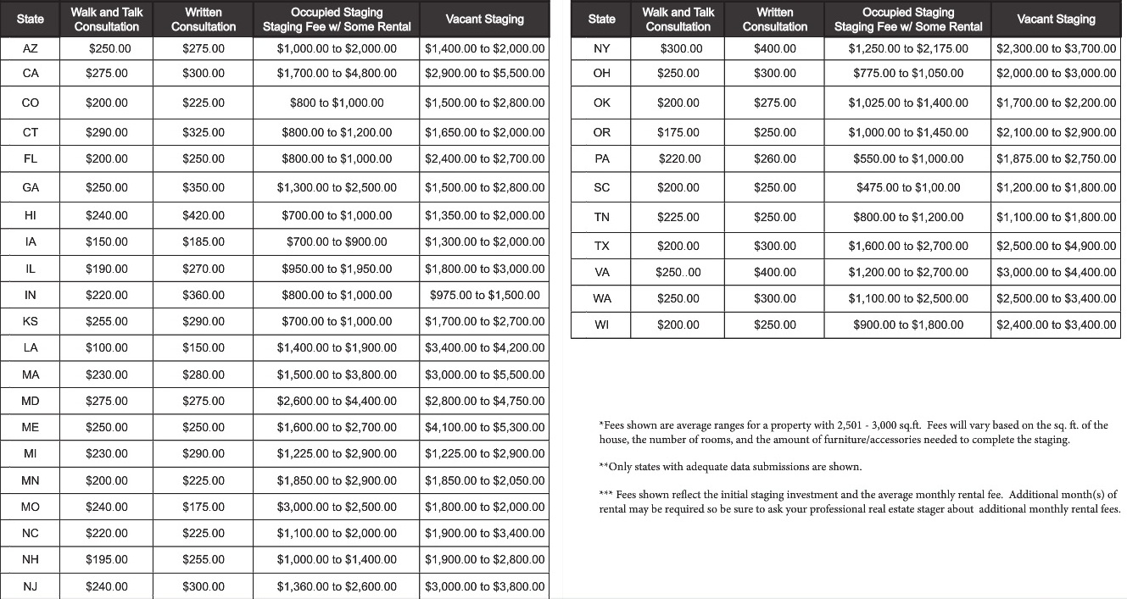

To see the full report, go to: <http://resa-hq.org/pricing/mobile/index.html>